**Final Year Project Report**

**Project Name:** Hospital Management Portal System

**Project Advisor: Kinza Sardar**

**Submitted by:**

**Aniqa Shehzadi (F2023065260)**

1. INTRODUCTION

* **Motivation**

In today's fast-paced healthcare environment, hospitals face challenges such as errors,

miscommunication, and inefficiencies caused by manual systems and paper-based records. To

address these issues, a centralized and automated Hospital Management System (HMS) is

essential. This project aims to design and develop a comprehensive HMS that streamlines

hospital operations, improves efficiency and accuracy, and ensures data accessibility, allowing

healthcare professionals to focus on delivering quality care while administrative tasks are

handled securely and effectively.

* **Project Overview**

In today’s rapidly evolving healthcare landscape, hospitals face numerous challenges in

managing their day-to-day operations efficiently. The reliance on manual systems and paper

based records often leads to significant drawbacks such as errors, delays, miscommunication,

and resource wastage. These inefficiencies can directly impact the quality of patient care and the

overall performance of healthcare facilities. Consequently, there is an increasing demand for a

robust digital solution to streamline hospital operations.

The motivation for this project stems from the need to address these operational

challenges through a comprehensive digital system. A **Hospital Management System (HMS)**

offers a centralized platform to manage various aspects of hospital administration and patient

care. By automating tasks such as patient registration, medical records management, appointment

scheduling, billing, inventory tracking, and staff coordination, an HMS significantly reduces

errors, enhances accuracy, and improves the accessibility of hospital data.

The proposed system aims to improve the overall efficiency of hospital workflows,

enabling healthcare professionals to focus on their primary goal: delivering high-quality care to

patients. With features such as secure data management, real-time reporting, and integration with

external systems like insurance providers and diagnostic labs, the HMS will ensure that both

clinical and administrative processes are handled seamlessly and securely.

* **Goals**

**1. Streamline Hospital Operations**

Automate and centralize core hospital functions such as patient registration,

appointment scheduling, medical records management, and billing to improve efficiency and

reduce errors.1. INTRODUCTION

3 of 7

**2. Enhance Data Accessibility and Security**

Ensure secure storage and retrieval of sensitive patient and hospital data while

providing role-based access to authorized users, adhering to data protection standards like

HIPAA or GDPR.

**3. Improve Patient Care**

Provide healthcare professionals with quick access to accurate and up-to-date patient

information, enabling better decision-making and more efficient care delivery.

**4. Integrate Seamlessly with External Systems**

Enable interoperability with external systems such as insurance providers, diagnostic

labs, and pharmacies to streamline workflows and improve service coordination.

**5. Support Scalability and Reliability**

Develop a system capable of handling growing hospital operations, ensuring consistent

performance, high availability, and easy adaptation to future requirements.

**System Functions**

The **Hospital Management System (HMS)** will include a wide range of functional

features to streamline hospital operations and improve healthcare delivery. These features are

designed to address critical needs across various departments and user roles within the hospital:

**1. Patient Management**

**.**

Registration and updating of patient records, including medical history, prescriptions, and

treatment plans.

**.**

Online appointment scheduling and management for improved patient convenience.

**2. Doctor and Staff Management**

**.**

Maintenance of doctor and staff profiles, duty allocation, and scheduling. 1. INTRODUCTION

4 of 7

**.**

Efficient management of staff payroll and attendance records.

3. Appointment Scheduling

**.**

A centralized system for booking, rescheduling, or canceling appointments.

**.**

Automated notifications to patients and doctors to ensure proper coordination.

**4. Medical Records Management**

**.**

Secure storage and retrieval of patient medical records, lab reports, and imaging results.

**.**

Ensuring data accuracy and ease of access for authorized users.

**5. Billing and Payments**

**.**

Generation of bills for consultations, treatments, and hospital services.

**.**

Support for multiple payment methods and insurance claim processing.

**6. Inventory and Pharmacy Management**

**.**

Real-time tracking of medicines and medical supplies.

**.**

Automated alerts for low-stock or expired items to prevent shortages.

**7. Report Generation**

**.**

Generation of detailed performance reports, including patient inflow, revenue, and

departmental statistics.

**.**

Analytical insights to support informed decision-making.

**8. Emergency Management**

**.**

Real-time monitoring and allocation of critical resources such as ICU beds and ventilators. 1. INTRODUCTION

5 of 7

**.**

Streamlined workflows for handling emergency cases.

**9. User Authentication and Authorization**

**.**

Secure role-based access for different user types (e.g., patients, doctors, administrators).

**.**

Ensuring that sensitive data is only accessible to authorized personnel.

**10. Integration with External Systems**

**.**

Seamless integration with insurance providers for claim processing.

**.**

Interfacing with external labs and diagnostic centers for sharing test results.

* **System Attributes**

**1. Performance**

**.**

High performance with minimal response times

**.**

Support for concurrent users

**2. Scalability**

**.**

Designed to accommodate future growth

**3. Data Security**

**.**

Encryption of sensitive data

**.**

Role-based access control

**.**

Compliance with standards like HIPAA and GDPR

**4. Availability**

**.**

99.9% uptime guarantee

**.**

Disaster recovery measures to prevent data loss

**5. Usability**

**.**

Intuitive and user-friendly interface

**.**

Accessibility across multiple platforms

**6. Maintainability**

**.**

Easy updates and debugging

**7. Interoperability**

**.**

Seamless integration with external systems to enhance functionality

**1.3**

* **Problem Statement**

Hospitals face significant challenges in managing their operations efficiently due to

reliance on manual systems and outdated processes. Issues such as delays in patient registration,

mismanagement of medical records, inefficient appointment scheduling, and errors in billing

create operational bottlenecks, reducing the quality of patient care. Furthermore, the lack of a

centralized platform for resource tracking, staff coordination, and integration with external

systems, such as insurance providers and diagnostic labs, complicates workflows. Hospitals also

struggle with data security and compliance with healthcare regulations. This project introduces a

comprehensive, secure Hospital Management System (HMS) to streamline hospital operations,

ensure data accuracy, and enhance patient and staff experiences. By automating administrative

tasks, managing medical resources, and enabling seamless coordination between departments,

the system aims to address these critical issues and improve the overall quality of healthcare

services.

**1.4 Objectives**

**Streamline Hospital Operations:**

Automate core administrative and clinical processes such as patient registration,

appointment scheduling, billing, and medical records management to improve efficiency and

reduce errors.

**Enhance Data Security and Compliance:**

Ensure the secure storage and handling of sensitive medical data, complying with

healthcare regulations such as HIPAA or GDPR.1. INTRODUCTION

7 of 7

**Improve Patient Care:**

Provide patients with a seamless experience through features like online appointment

booking, access to medical history, and real-time communication with healthcare providers.

**Facilitate Resource Management:**

Enable real-time tracking and management of hospital resources, such as beds,

equipment, and inventory, to optimize resource utilization.

**Enable Integration and Interoperability:**

Provide integration with external systems like insurance providers and diagnostic labs to

streamline workflows and enhance collaboration.

**Support Decision-Making with Analytics:**

Offer detailed reports and analytics to help hospital administrators monitor performance,

track revenue, and make informed decisions for operational improvements.

**Promote Scalability and Flexibility:**

Develop a system that can adapt to the evolving needs of healthcare institutions, allowing

for easy upgrades and the addition of new features.

**Enhance Staff Efficiency:**

Provide tools for staff scheduling, duty management, and payroll tracking to ensure better

coordination and productivity among hospital personnel.

**2. Domain Analysis**

**2.1**

**Customers**

The primary customers of the online Hospital Management System (HMS) are patients,

healthcare providers, hospital administration, support staff, suppliers, and admins.

**2.2**

**Stakeholders**

|  |  |
| --- | --- |
| Patient | Access medical records, receive treatment information, and book  appointments online. |
| Healthcare Provider  (Doctor, Nurse) | Manage patient care, update medical records, and administer  treatments. |
| Admin | Oversee system operations, manage user access, and ensure data  security and compliance |
| Staff (Faculty,  Pharmacy) | Handle administrative tasks and manage pharmacy inventory and  prescriptions. |
| Back End (Inventory) | Monitor and manage hospital inventory, ensuring timely restocking  of supplies |
| Support Staff | Maintain hospital facilities and equipment, ensuring everything is in  proper working order. |

**2.3 Affected Groups with social or economic impact**

**1. Patients**

**Social Impact:**

- Improved access to healthcare services through online appointment booking and digital

medical records.

- Enhanced patient experience with reduced waiting times and streamlined processes.

**Economic Impact:**

- Reduced out-of-pocket expenses due to efficient billing and integration with insurance

providers.

- Cost savings for patients by avoiding unnecessary visits through telemedicine integration.

**2. Doctors and Healthcare Staff**

**Social Impact:**

- Improved efficiency through easy access to patient medical records and automated scheduling.

- Better work-life balance due to reduced administrative burden.

**Economic Impact:**

- Enhanced productivity, leading to better patient outcomes and higher satisfaction.

- Increased opportunities for additional income through teleconsultations or specialized

services.

**3. Hospital Administration**

**Social Impact:**

- Better coordination between departments, leading to improved service quality.

- Enhanced reputation due to better patient care and management.

**Economic Impact:** 4 of 11

- Cost savings through efficient resource utilization and inventory management.

- Higher revenue due to increased patient inflow and better service delivery.

**4. Insurance Companies**

**Social Impact:**

- Easier claim processing and transparency in patient treatment histories.

- Improved collaboration between hospitals and insurers, benefiting patients.

**Economic Impact:**

- Reduction in fraudulent claims through accurate record-keeping.

- Faster processing times, reducing operational costs for insurance companies.

**5. IT Professionals and Software Developers**

**Social Impact:**

- Increased demand for skilled professionals in HMS development and maintenance.

- Opportunities for career growth and specialization in healthcare IT.

**Economic Impact:**

- Job creation in IT for system development, implementation, and support.

- Higher salaries and economic growth in the IT sector.

**6. Regional Healthcare Providers**

**Social Impact:**

- Improved access to healthcare technology in remote and underdeveloped areas.

- Standardization of healthcare processes across regions.

**Economic Impact:**

- Growth opportunities for smaller hospitals and clinics through efficient management.

- Cost reduction in operational overheads, increasing profitability.

**7. Pharmaceutical Companies and Vendors**

**Social Impact:**

- Better demand forecasting for medicines and medical supplies. 5 of 11

- Timely availability of medications for patients.

**Economic Impact:**

- Increased orders due to streamlined inventory management in hospitals.

- Reduced losses caused by expired stock through better tracking.

**8. Educational Institutions**

**Social Impact:**

- Access to case studies and real-world examples for students in healthcare and IT.

- Better research opportunities in healthcare technology and data analytics.

**Economic Impact:**

- Collaboration with hospitals for internships and projects, creating skilled graduates.

- Opportunities for funding and partnerships with healthcare providers.

**2.4 Dependencies/ External Systems**

Here are some potential dependencies or external systems/products that the project may rely on

for its completion:

**1. Cloud Hosting Providers**

**Dependency:** Reliance on cloud computing services to host the HMS for scalability,

reliability, and accessibility.

**2. Medical Equipment and IoT Integration**

**Dependency:** Integration with IoT devices and medical equipment to monitor and collect

patient vitals in real-time.

**3. Authentication and User Management APIs**

**Dependency:** APIs for secure user authentication and management, including role-based

access control for doctors, staff, and patients.

**4. Pharmacy and Inventory Management Systems**

**Dependency:** Integration with external pharmacy and inventory systems to manage drug stock

levels, orders, and vendor relationships. 6 of 11

**5. Insurance and Billing Systems**

**Dependency:** Integration with insurance providers and billing systems to manage claims

processing and payments.

**6. Shipping and Logistics Services**

**Dependency:** Coordination with shipping and logistics companies to manage the delivery of

medical supplies and laboratory samples.

**7. Security Systems and Protocols**

**Dependency:** Ensuring integration with robust security protocols to safeguard sensitive

medical and personal data.

**8. Mobile Platforms (iOS/Android)**

Dependency: Compatibility and development for mobile platforms to allow patients and staff

access to the HMS through smartphones or tablets.

**9. APIs for Telemedicine and Virtual Consultations**

**Dependency:** Integration with APIs that enable telemedicine features like video consultations,

chat, and remote patient monitoring.

**10. Analytics and Reporting Tools**

**Dependency:** Integration with analytics tools to monitor system performance and generate

hospital performance reports.

**11. Laboratory and Diagnostic Systems**

**Dependency:** Integration with external lab systems to streamline test orders and result

retrieval.

**3.**

* **Requirement Analysis**

**3.1 Requirements**

There are two categories of requirements:

1. Functional Requirements

2. Non-Functional Requirements7 of 11

* **Functional Requirements**

**1. Patient Management:**

• Register new patients and update existing patient records.

• Maintain patient medical histories, prescriptions, and treatment plans.

• Allow patients to book, reschedule, and cancel appointments online.

**2. Appointment Scheduling:**

• Enable patients to book appointments with healthcare providers.

• Notify both patients and healthcare providers of scheduled appointments.

• Manage availability of doctors and other healthcare staff.

**3. Medical Records Management:**

• Store and manage patient medical records securely.

• Provide access to lab reports, imaging results, and treatment history.

• Ensure accuracy and quick retrieval of medical data.

**4. Billing and Payments:**

• Generate bills for consultations, treatments, and other services.

• Support multiple payment methods (e.g., cash, card, online payments).

• Handle insurance claims processing and track payment history.

**5. Pharmacy Management:**

• Track inventory of medicines and medical supplies.

• Manage prescriptions and provide alerts for low stock or expired medicines.

**6. Staff Management:**

• Maintain profiles of doctors, nurses, and other staff.

• Manage staff schedules, duty allocations, and payroll information.

**7. Inventory Management:**

• Monitor and manage hospital inventory, including medical supplies and equipment.

• Generate alerts for replenishing stocks and manage vendor details.8 of 11

**8. Reporting and Analytics:**

• Generate reports on patient inflow, revenue, and hospital performance.

• Provide analytics to aid in decision-making and operational improvements.

**9. User Authentication and Authorization:**

• Implement secure login for different user roles (admin, doctor, patient, etc.).

• Define and enforce role-based access controls to system functionalities.

**10. Integration with External Systems:**

• Integrate with insurance providers for claims processing.

• Interface with external diagnostic labs for test results.

**Non-Functional Requirements**

**1. Performance:**

• The system should support simultaneous access by multiple users with minimal response

time.

• Ensure the system can handle peak loads efficiently.

**2. Scalability:**

• The system should be scalable to accommodate future growth in user base and data

volume.

**3. Security:**

• Implement robust security measures, including data encryption and secure access control.

• Ensure compliance with healthcare regulations like HIPAA or GDPR.

**4. Availability:**

• Ensure high availability with an uptime of at least 99.9%.

• Implement disaster recovery mechanisms to prevent data loss.

**5. Usability:**9 of 11

• Provide a user-friendly interface that is intuitive and easy to navigate for all user roles.

• Ensure the system is accessible across various devices (desktop, mobile, tablets).

**6. Maintainability:**

• Design the system to be easily maintainable, allowing for quick updates and bug fixes.

• Ensure that system documentation is comprehensive and up-to-date.

**7. Interoperability:**

• Ensure the system can easily integrate with third-party systems such as insurance

providers and diagnostic labs.

• Support standard healthcare data formats for smooth data exchange.

**8. Reliability:**

• Ensure that the system performs reliably under all conditions and handles errors

gracefully.

**9. Authenticity:**

• Before allowing access to sensitive data, it's crucial to confirm the identity of the user.

**3.2**

**List of Actors**

**1. Patient:**

The patient is the end user of the hospital system, utilizing it for various medical services. Their

responsibilities include registering on the platform and keeping their personal profiles up to date.

They are responsible for booking appointments with doctors and have the flexibility to

reschedule or cancel these appointments if necessary. Patients also access their medical records,

prescriptions, and test results through the system. Additionally, they provide feedback and

reviews regarding the hospital services and make payments for medical services, while also

accessing their billing history.

**2. Doctor:**

The doctor provides medical consultation and treatment to patients through the system. They are

responsible for managing their schedules and appointments, ensuring that they can meet with

patients efficiently. Doctors access patient medical histories, lab reports, and test results to

diagnose illnesses and prescribe appropriate treatments or medications. They also update patient

records with details of treatments and follow-up care and communicate with patients regarding

their medical conditions and care plans.10 of 11

**3. Nurse/Medical Staff:**

Nurses and medical staff play a critical role in assisting with patient care and hospital operations.

They are responsible for monitoring patient vitals and ensuring that this information is accurately

updated in the system. They assist doctors during procedures or treatments and manage tasks

such as administering medications. Additionally, they ensure that hospital rooms are well

maintained and that medical supplies are properly stocked and organized.

**4. Administrator (Admin):**

The administrator oversees the overall operations of the hospital system, ensuring that it runs

smoothly. Their responsibilities include managing user roles and access controls within the

platform, overseeing patient registration, and ensuring that patient records are correctly managed.

Administrators monitor doctor and staff schedules, generate performance reports, handle billing

processes, manage payments and insurance claims, and ensure the platform's security while

resolving any system issues that arise.

**5. Pharmacist:**

The pharmacist manages the hospital's pharmacy and ensures that the medication inventory is

well-maintained. They are responsible for dispensing medications as prescribed by doctors and

ensuring that patients receive the correct medications. Pharmacists monitor the inventory of

drugs, ensuring that stock levels are adequate and alerting administrative or procurement staff

about low stock or expired medicines. They also maintain accurate records of all issued and

returned medications.

**6. Laboratory Technician:**

The lab technician handles diagnostic tests and is responsible for providing accurate medical

reports. They conduct various medical tests, such as blood tests and imaging scans, as prescribed

by doctors. They ensure that test results are uploaded to the patient's medical records promptly.

Additionally, they are responsible for maintaining and calibrating lab equipment to ensure

accuracy and reliability in test results.

**7. Receptionist**:

The receptionist is responsible for front-desk operations and acts as the first point of contact for

patients. They handle patient inquiries, guide them through the hospital services, and assist with

scheduling and confirming appointments. Receptionists register new patients and maintain their

records, processing basic billing and payment transactions as part of their role.

**8. System Admin/IT Staff:**11 of 11

The system admin ensures that the HMS platform functions efficiently and without disruption.

They are responsible for maintaining the platform's infrastructure, resolving technical issues, and

performing data backups to ensure data security. System admins also plan for disaster recovery,

ensure compliance with data privacy regulations, and update the system with new features or

modules as needed to enhance functionality.

***UseCase Diagram:***

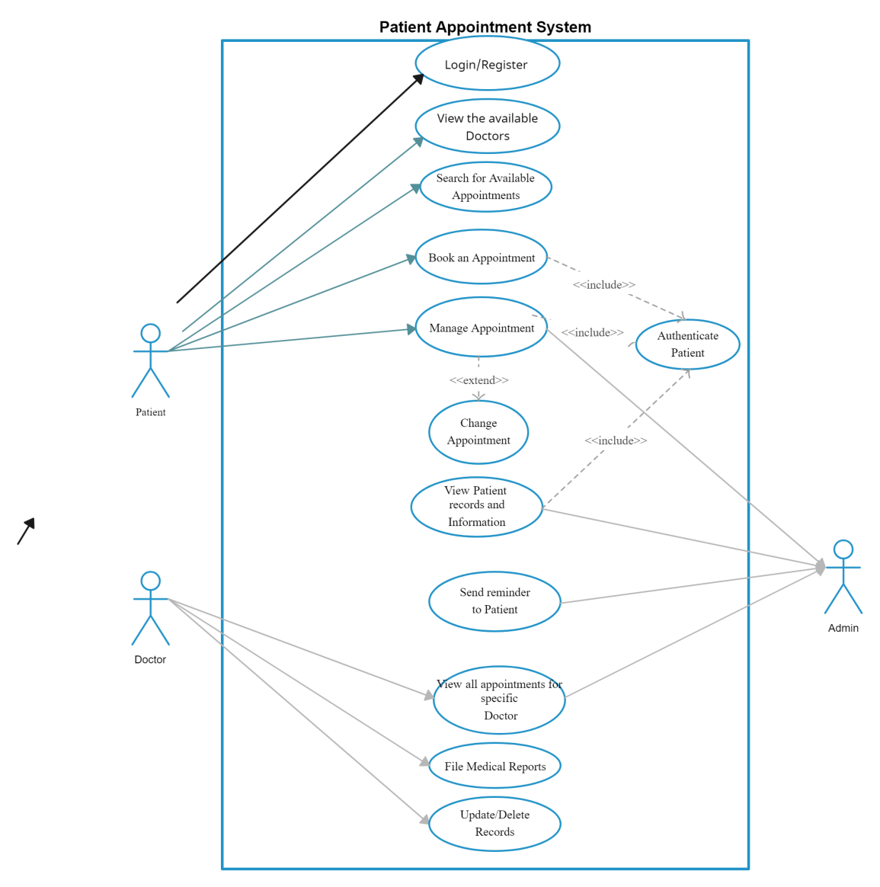

**DFD LEVEL 0**

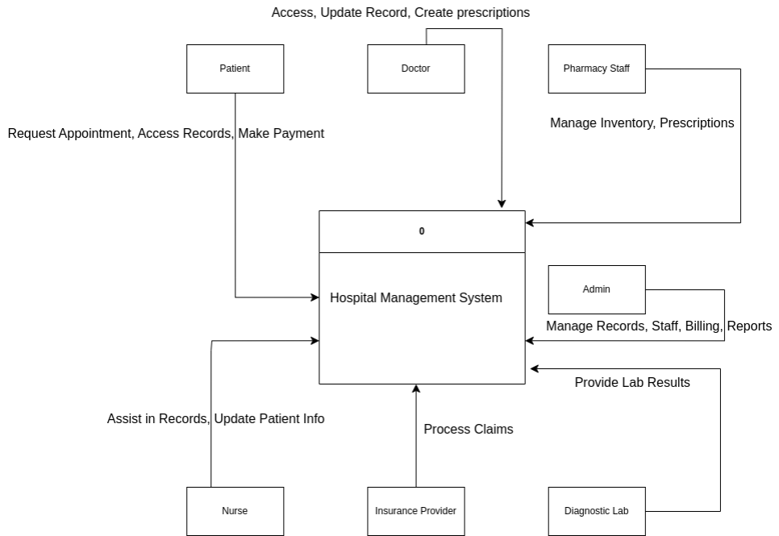

**DFD LEVEL 1**

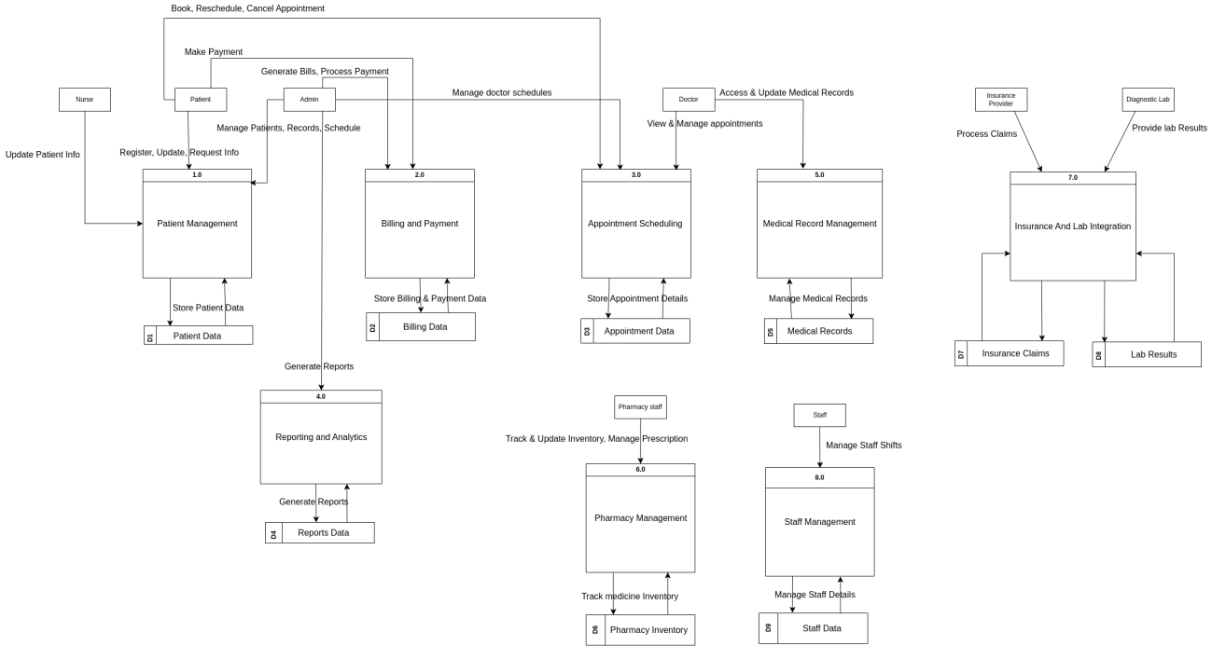

**SEQUENCE DIAGRAM**

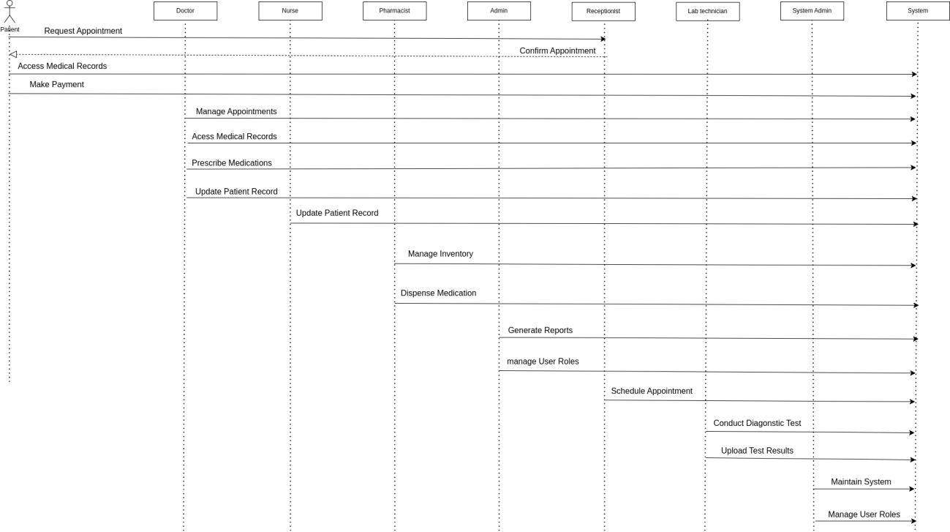

**CLASS DIAGRAM**

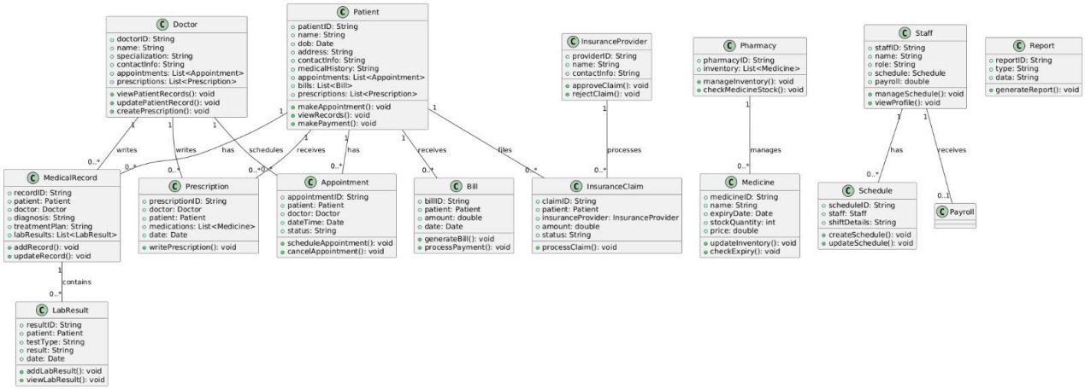

**ACTIVITY DIAGRAM**

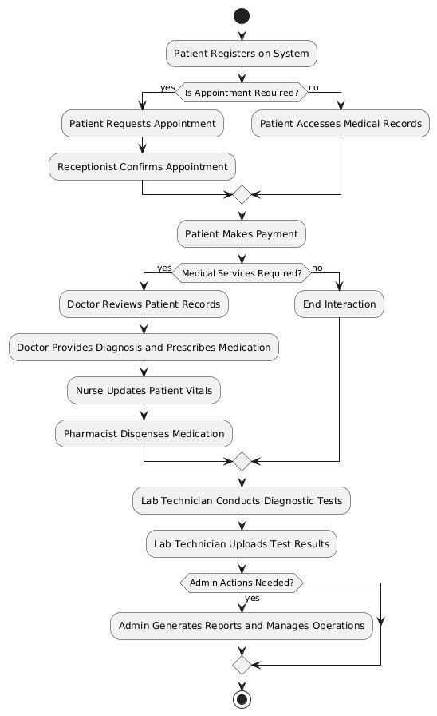

**Architecture Diagram:**

Layerd Achitecture Diagram.

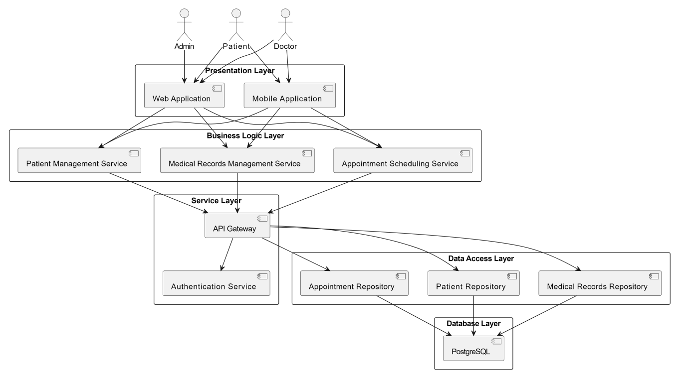

Test Case:

| **Test Case ID** | **Feature** | **Description** | **Steps** | **Expected Result** |
| --- | --- | --- | --- | --- |
| **TC01** | **Patient Registration** | Verify patient registration process. | Fill form, submit. | Patient is registered. |
| **TC02** | **Doctor Registration** | Test new doctor addition. | Fill details, submit. | Doctor is added. |
| **TC03** | **Appointment Booking** | Check appointment scheduling. | Select doctor, date, confirm. | Appointment is booked. |
| **TC04** | **Appointment Cancellation** | Verify appointment cancellation. | Select appointment, cancel. | Appointment is removed. |
| **TC05** | **Billing System** | Test bill generation. | Add patient services, generate bill. | Correct bill is generated. |
| **TC06** | **Patient Search** | Check search functionality. | Enter patient name/ID, search. | Matching patient details appear. |
| **TC07** | **Doctor Availability** | Verify doctor's available slots. | Select doctor, view schedule. | Available slots are displayed. |
| **TC08** | **Medicine Inventory** | Ensure medicine stock is updated. | Add new stock, update inventory. | Inventory reflects changes. |
| **TC09** | **User Login** | Check authentication. | Enter credentials, login. | User logs in successfully. |
| **TC10** | **Report Generation** | Verify patient reports can be generated. | Select patient, generate report. | Report is displayed/downloaded. |
|  |  |  |  |  |
|  |  |  |  |

**Gant Chart:**

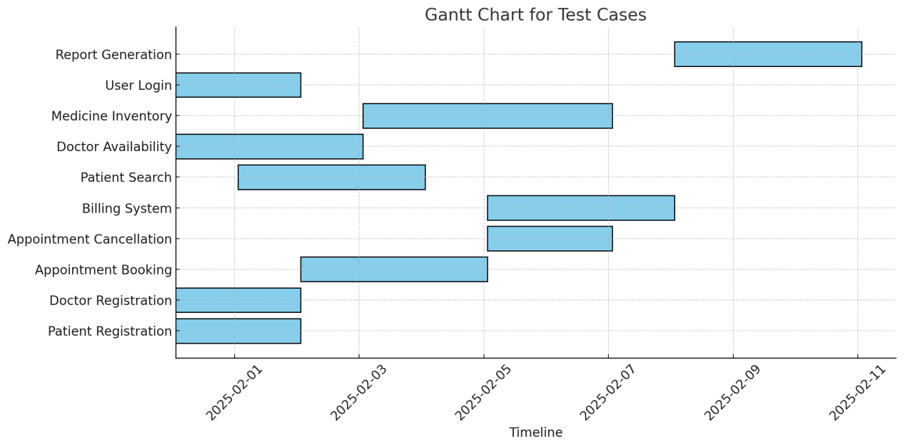

**Prototypes of Hospital Management system**



**Login Page:**

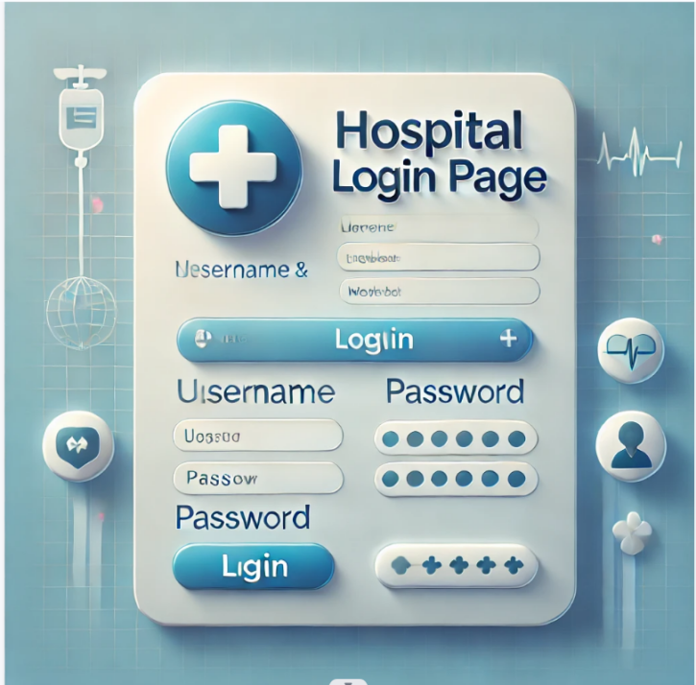

**Dashborad Feacture:**

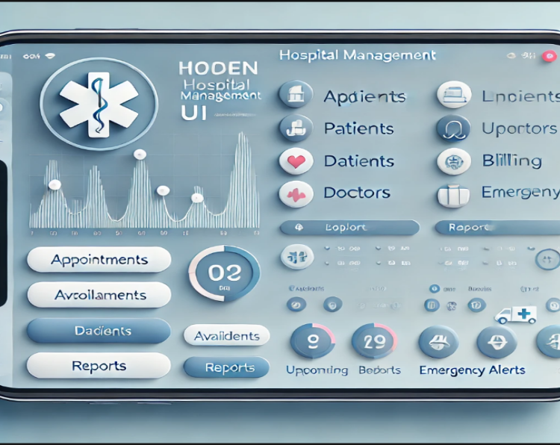

**Patient Management page:**

